Given the root of a binary tree and an integer targetSum, return true if the tree has a **root-to-leaf** path such that adding up all the values along the path equals targetSum.

A **leaf** is a node with no children.

**Example 1:**

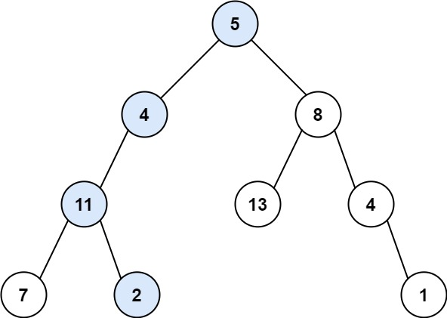

Input: root = [5,4,8,11,null,13,4,7,2,null,null,null,1], targetSum = 22  
Output: true  
Explanation: The root-to-leaf path with the target sum is shown.

**Example 2:**

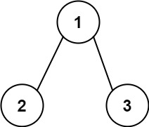

Input: root = [1,2,3], targetSum = 5  
Output: false  
Explanation: There two root-to-leaf paths in the tree:  
(1 --> 2): The sum is 3.  
(1 --> 3): The sum is 4.  
There is no root-to-leaf path with sum = 5.

**Example 3:**

Input: root = [], targetSum = 0  
Output: false  
Explanation: Since the tree is empty, there are no root-to-leaf paths.

**Constraints:**

* The number of nodes in the tree is in the range [0, 5000].
* -1000 <= Node.val <= 1000
* -1000 <= targetSum <= 1000